Fractional Differencing Test
1/10/09
Nile River Data
Beran Results Reproduced Results
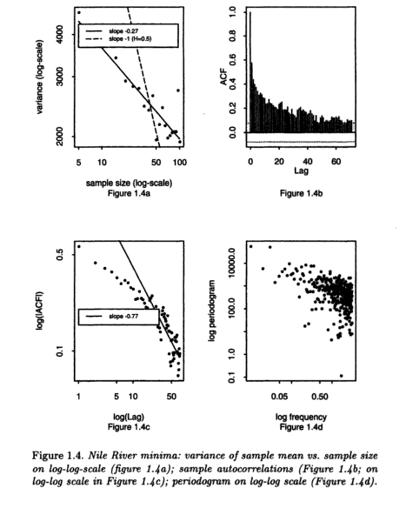
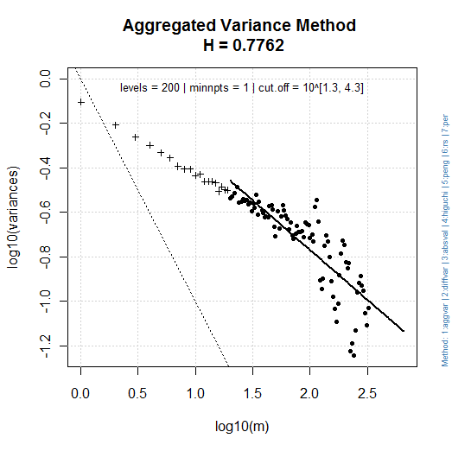 | 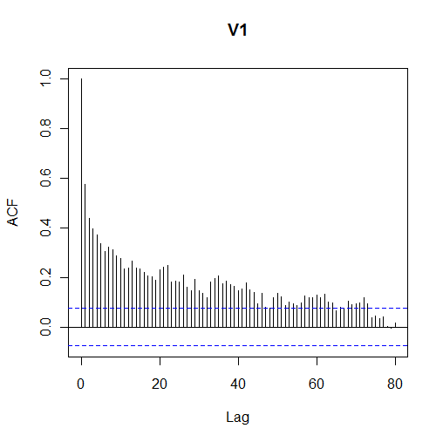
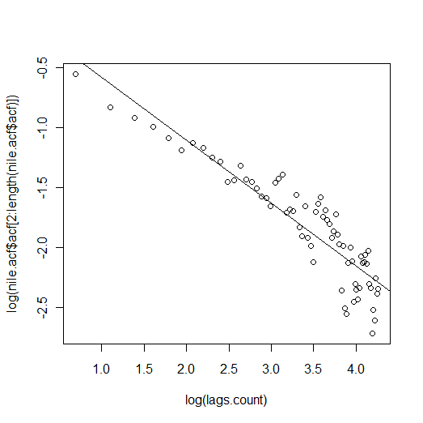 | 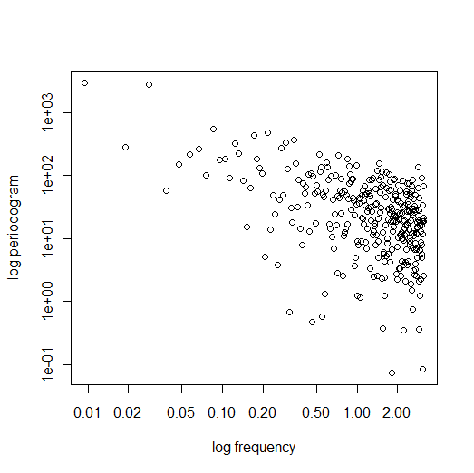

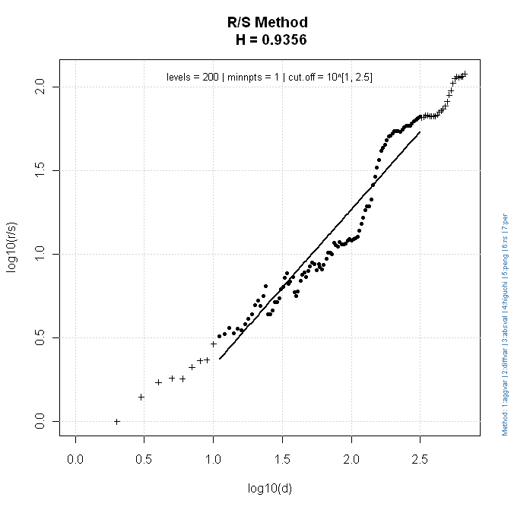
FARIMA(0,d,0)
H = 0.837425
95%-CI for H: [ 0.7864071 , 0.888443 ]

FGN
H = 0.8991992
95%-CI for H: [ 0.839536 , 0.9588624 ]

